911-21 guruh talabasi Omonbayev Jaloliddinning

Tarmoq xavfsizligi fanidan mustaqil ishi.

Oliy ta’lim tarmog’ini qurish.

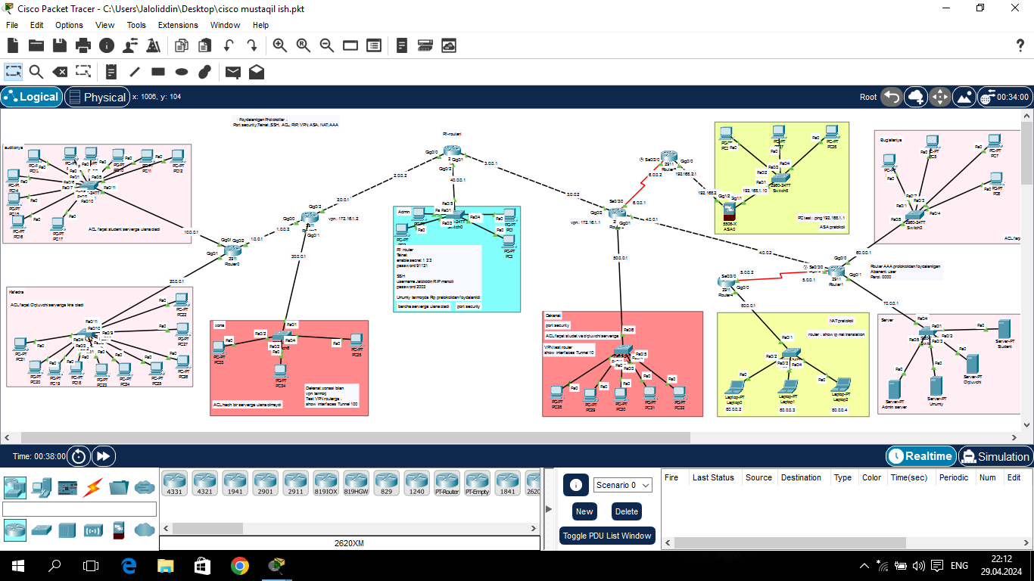

Oliy ta’lim tarmog’ida 9 ta xonalarga bo’ingan bo’lib harbir xonada shu xona foydalanilishiga qarab protikollaridan foydalanilgan.

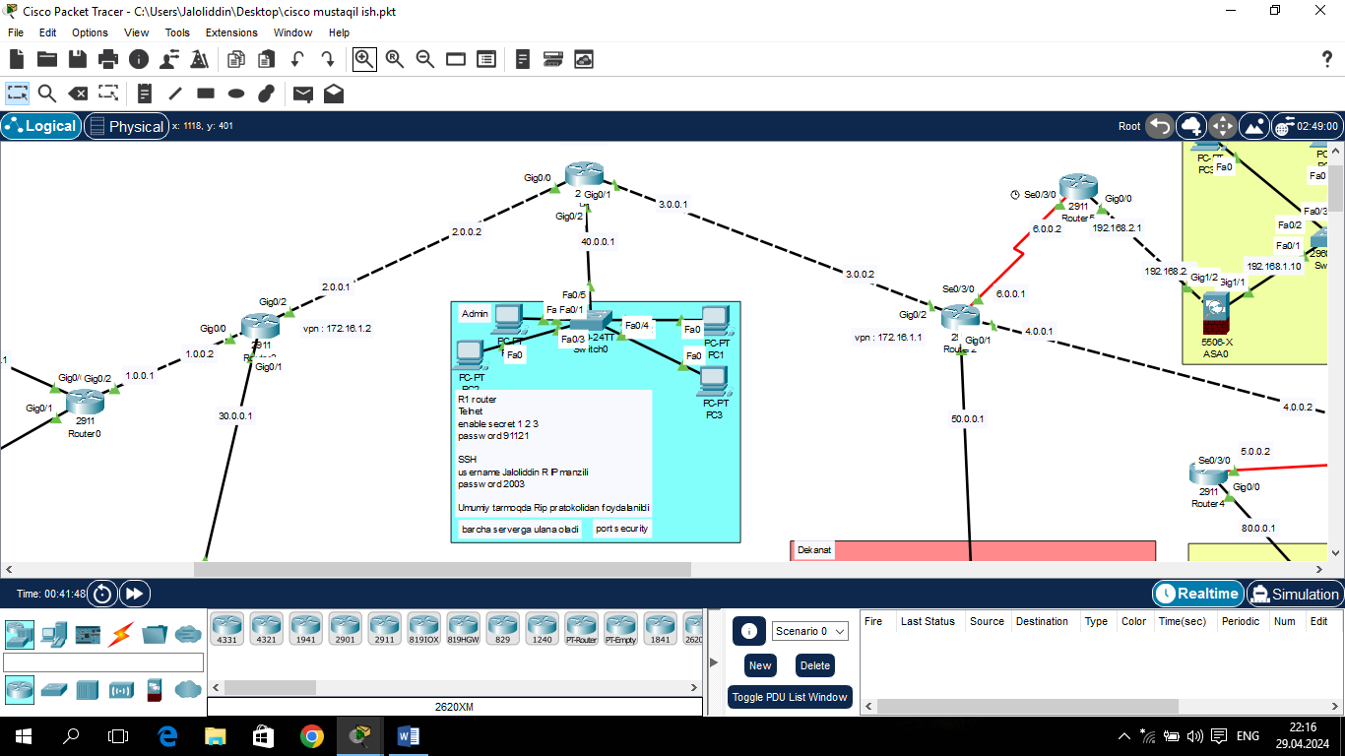

Admin xonasi bu bo’limda routerga telnet ssh qo’llanildi:

**Telnet:**

* en
* conf t
* hostname r1
* enable secret 1 2 3
* line vty 0
* password 9 1 1 2 1
* login
* loggin synchronous
* exec-timeout 10
* transport input telnet
* ex

**SSH:**

* en

password : 1 2 3

* conf
* ip domain name ubtuit.uz
* username Jaloliddin password 1 2 3
* crypto key generate rsa
* ip ssh version 2
* line vty 1 3
* transport input ssh
* login local
* logging synchronous
* ex
* service password-encryption

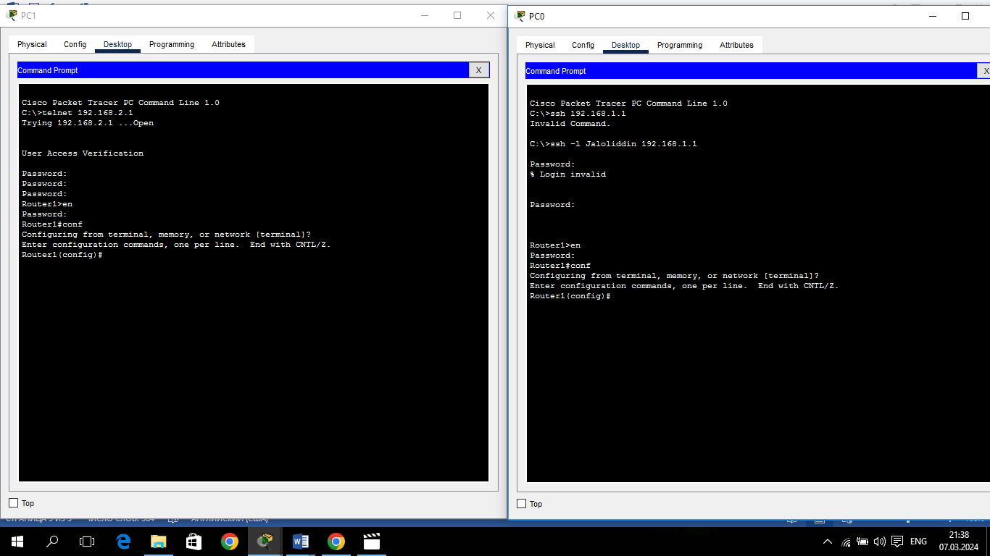

**Switchda port security.**

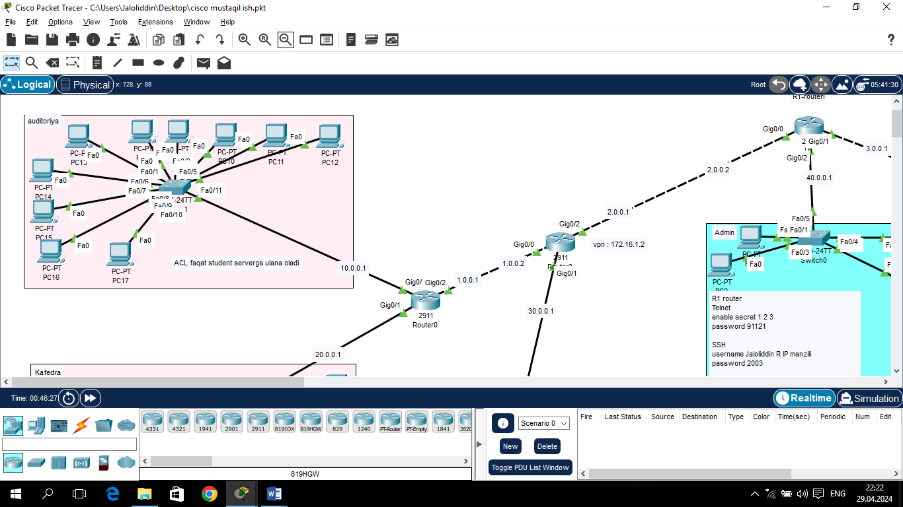

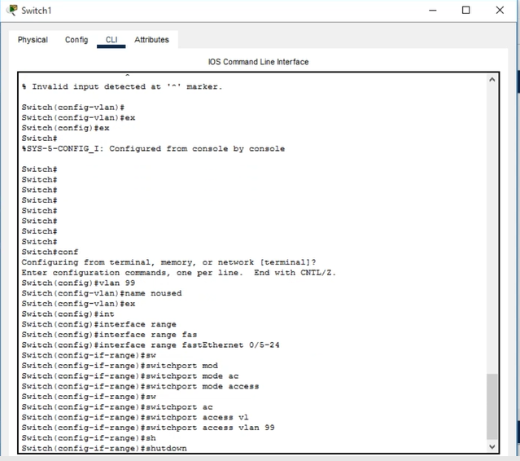

1-rasm.

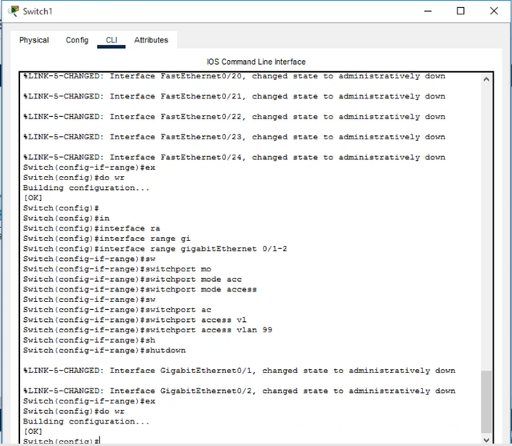

2-rasm.

Yuqoridagi rasmlarda (1-2 rasmlar) switchning configuratsiya qismiga kirgan holda vlan 99 vlani yaratilib f0/5-24 va g0/1-2 porlari shu vlanga biriktrildi va vlan 99 o’chirib qo’yildi. Natijada ushbu portlarga qurilmalar ulanib bilmaydi.

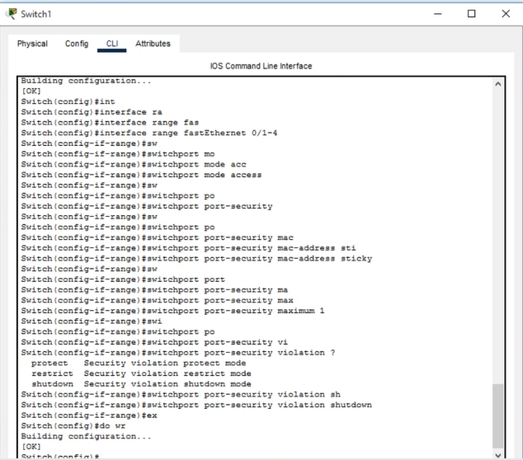

3-rasm.

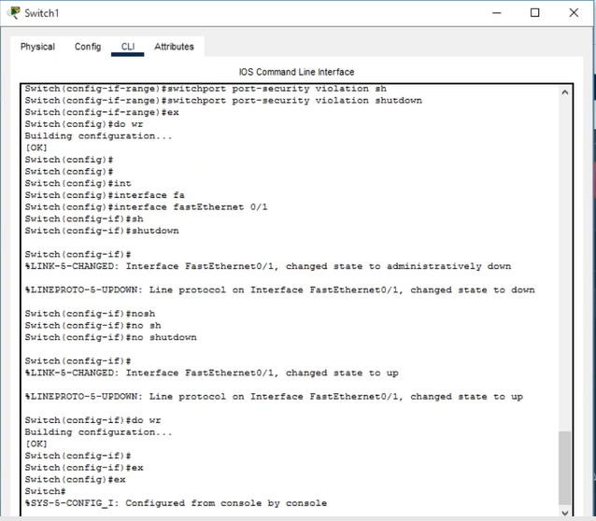

4-rasm.

Endi bizga kerak f0/1-4 portlarida port security ni yoqib oldik (3-4 rasmlar).

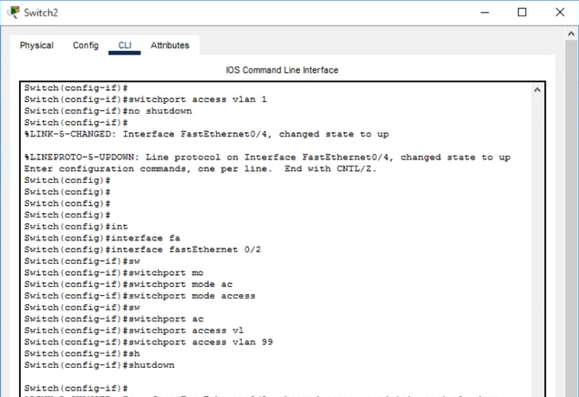

5-rasm.

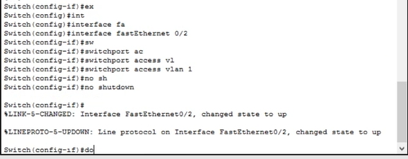

7-rasm.

F0/2 portini qayta yoqish uchun 7-rasmdagilarni kiritamiz.

**RIP protokoli. Router1:**

* en
* conf t
* hostname R1
* int f0/0
* ip add 192.168.12.1 255.255.255.0
* no sh
* int f0/1
* ip add 192.168.1.1 255.255.255.0
* no sh
* router rip
* network 192.168.1.0
* network 192.168.12.0

**Router2:**

* en
* conf t
* hostname R2
* int f0/0
* ip add 192.168.12.2 255.255.255.0
* no sh
* int f0/1
* ip add 192.168.2.1 255.255.255.0
* no sh
* router rip
* network 192.168.2.0
* network 192.168.12.0

**ACL protokoli router :**

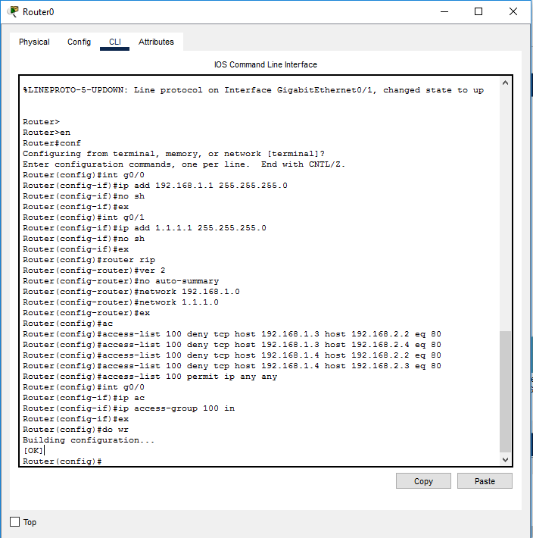

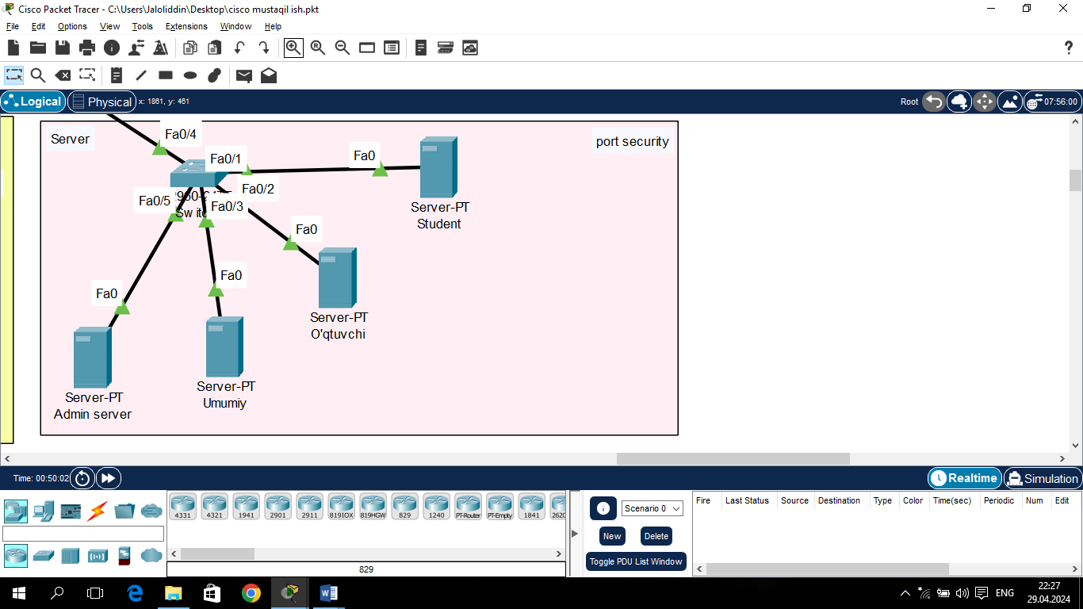

Har bir xona kompyuterlari o’ziga tegishli serverga murojaat qila oladi(ACL).

**NAT.**

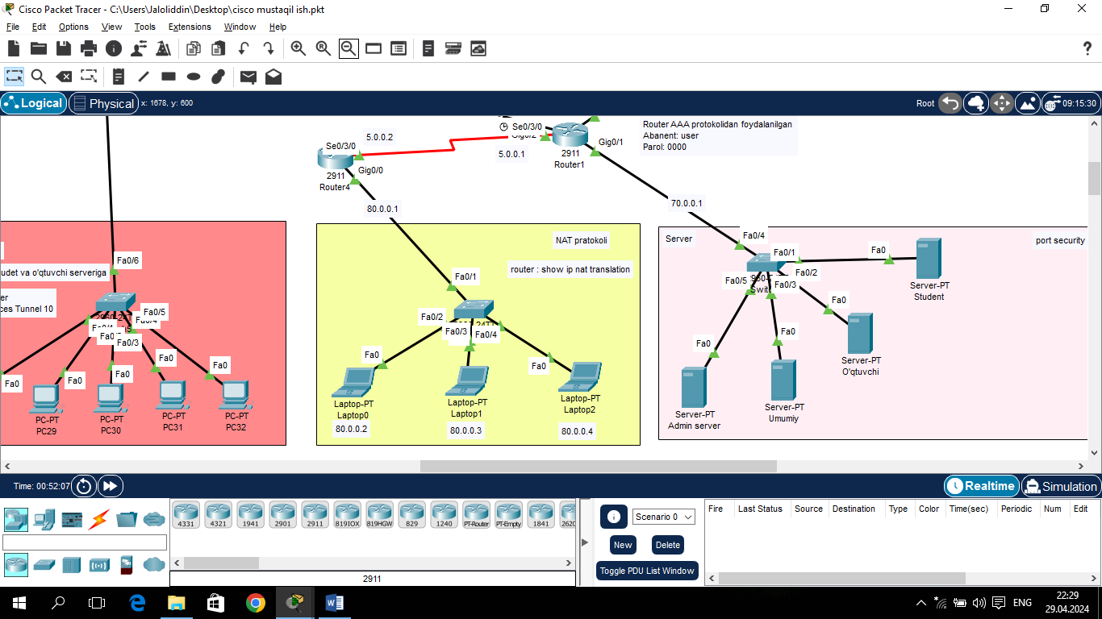

Ushbu xonada NAT protokolidan foydalanildi.

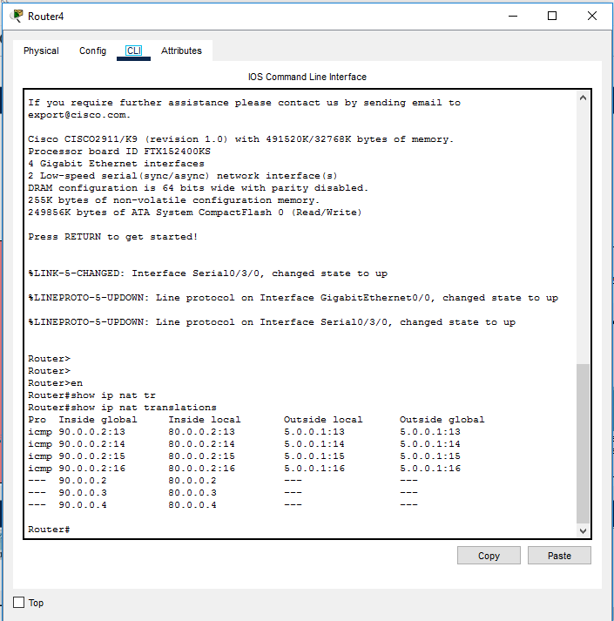

**ASA pratokoli qo’llanilgan xona:**

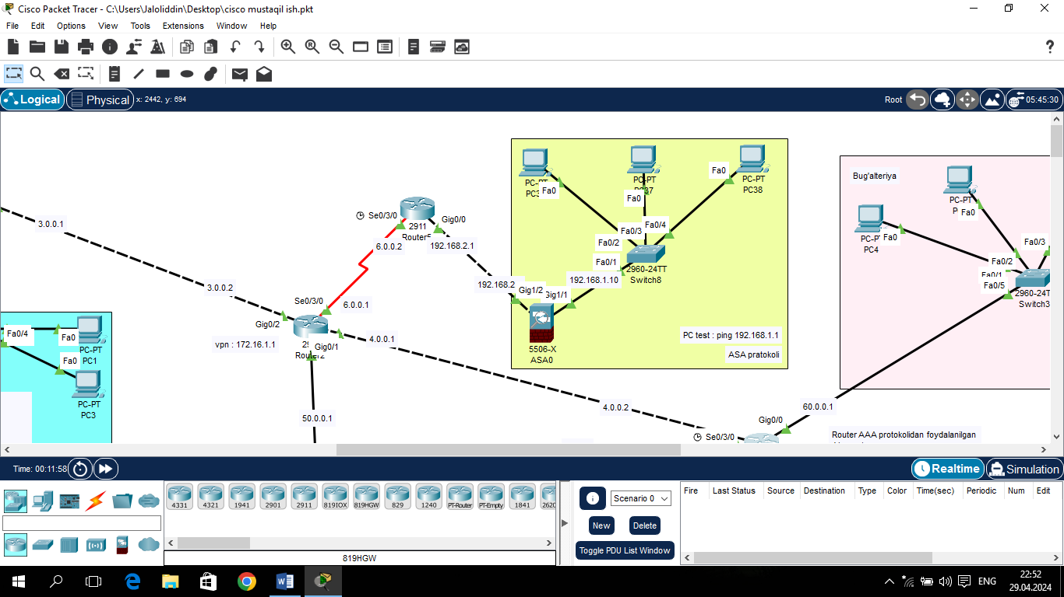

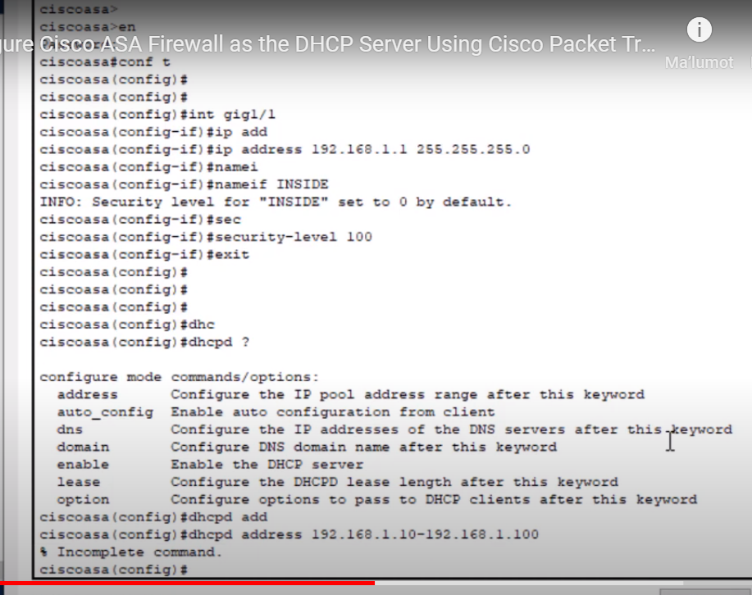

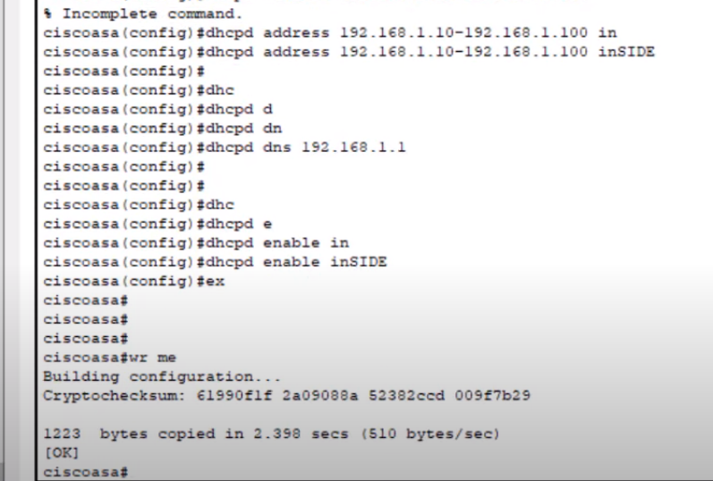

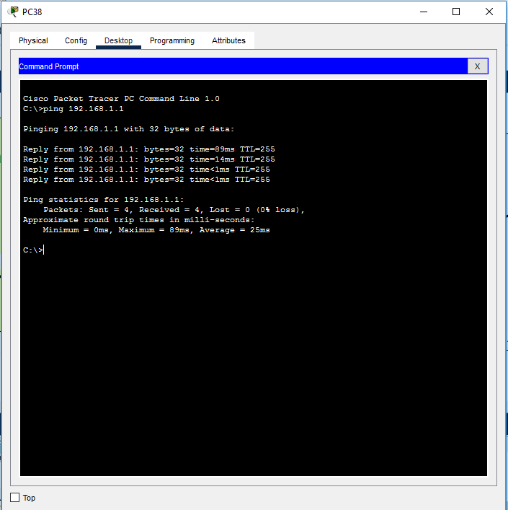

**VPN.**

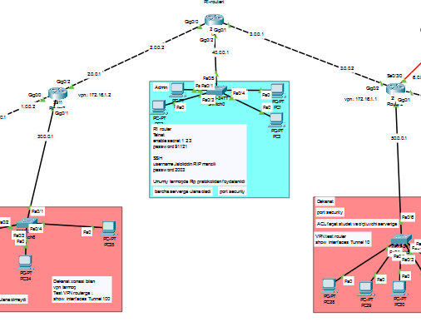

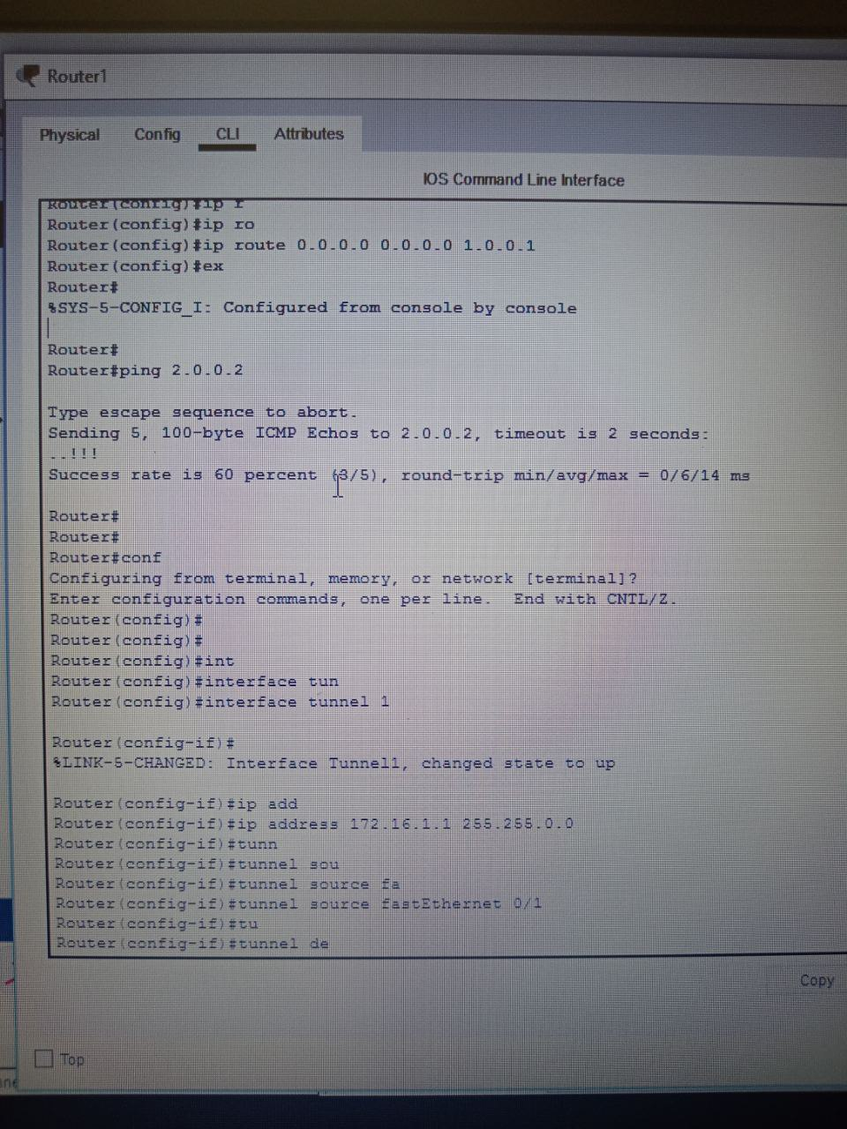

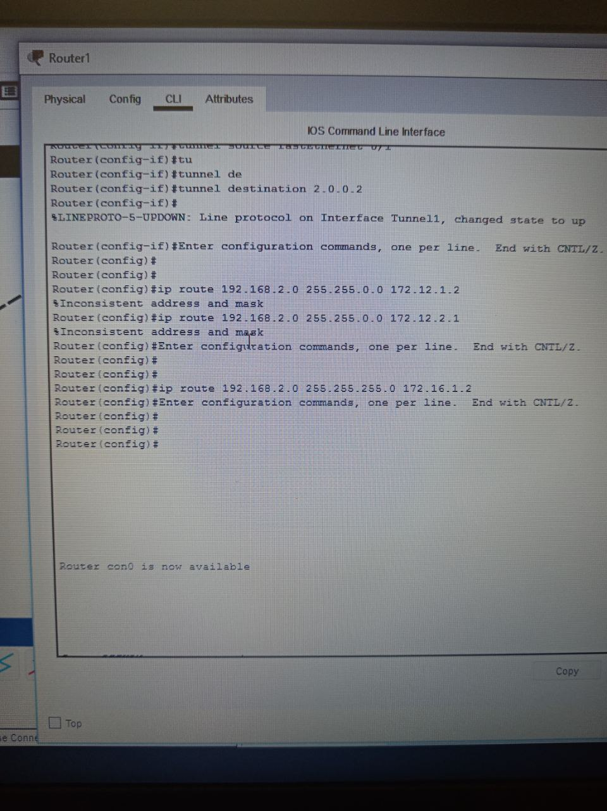

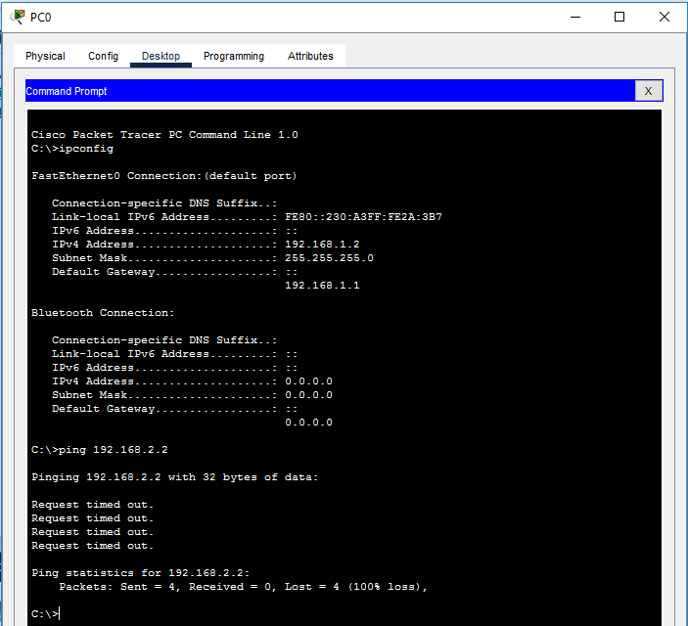

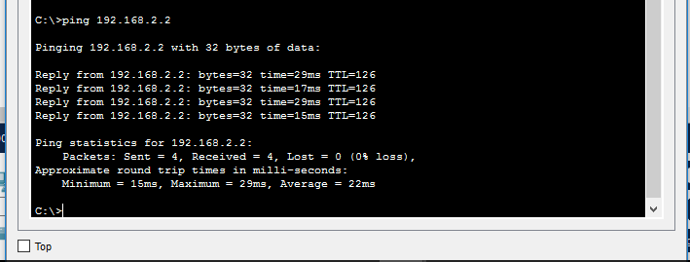

**AAA.**

